

IBM® Security® Software
IBM Tivoli Directory Integrator (TDI)
OpenPages Connector
Document version 1.0

Eddie Hartman
Security Directory Integrator
Developer




© Copyright International Business Machines Corporation 2014.
US Government Users Restricted Rights – Use, duplication or disclosure restricted by GSA ADP Schedule Contract with IBM Corp.

Contents
List of Figures iv
List of Tables v
Revision History 6
1 Introduction 7
2 Using the OpenPages Connector 8
2.1 Installation 8
2.1.1 Installing the connector 8
2.1.2 Configuring it 8
2.2 Attribute Maps 10
3 OpenPages Connector Examples 12
3.1 Creating Incidents in OpenPages 12
4 Conclusion 13
Appendix 14
References 15

List of Figures
Figure 1: OpenPages Connector Connection tab 9
Figure 2: OpenPages Connector Connection tab – Advanced Section 10
Figure 3: OpenPages Incident schema 11

List of Tables
Table 1: OpenPages Connector parameters 9
Table 2: OpenPages Connector advanced parameters 10
Table 3: Special CouchDB Connector Attributes 11

Revision History
Date | Version | Revised By | Comments
15 Oct 2014 | 0.9 | EH | Started the doc

Introduction
IBM® Tivoli Directory Integrator (as of release 7.2 now named Security Directory Integrator - SDI) enables synchronization, transformation and migration of generic and identity data across heterogeneous systems, helping organizations maintain consistent and trusted data across multiple resources.
OpenPages is an IBM system designed to allow clients manage risk and compliance initiatives across the enterprise, helping businesses to reduce loss, improve decision-making about resource allocation, and optimize business performance.
This document details the OpenPages Connector which can be used to read and write GRC objects in OpenPages.

Using the OpenPages Connector
This chapter provides tutorial exercises that illustrate how to use the CouchDB Connector in TDI AssemblyLines.

Installation
The following systems must be installed in order to proceed with the tutorial:
- TDI 7.1.1 or later version
- Access to a running OpenPages instance
- the OpenPages Connector
TDI installation is not outline here. Consult the product documentation for instructions on installing the system on a specific platform.
https://ibm.biz/BdFRAw (Online docs for TDI)
The section outlines installation of the OpenPages connector.

Installing the connector
Make sure the latest patch level of TDI v7.1.1 (or later version) is installed on your machine. You can find the recommended patch level for all TDI versions here: http://www.tdi-users.org.
The OpenPages Connector itself can be downloaded from here. This jar file must be made available to TDI and then TDI must be restarted.

Configuring it
Here is what the OpenPages Connector looks like in the TDI Configuration Editor (CE).
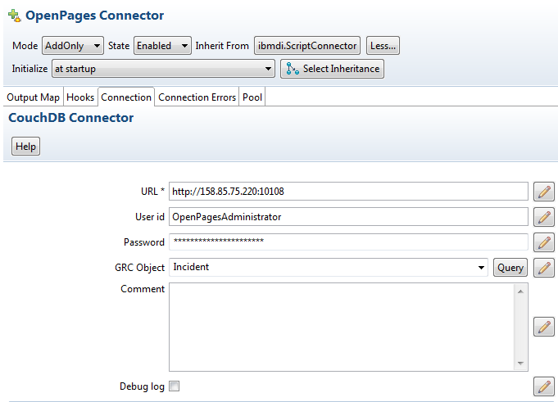
Figure 1: OpenPages Connector Connection tab
The various parameters here are described in the table below.
Table 1: OpenPages Connector parameters
Parameter name | Description
URL | The URL to the OpenPages system, including hostname and port.
User id | User id for authentication.  By default no authentication is required for CouchDB.
Password | Password associated with the above User id.
GRC Object | The name of the GRC Object type that the Connector will work with.  Note that for creating new objects then the type can be specified in the Output Map for each item written.
Comment | User comments.
Debug log | Causes debug messages to be written to the log.
The Advanced section contains a few more options.
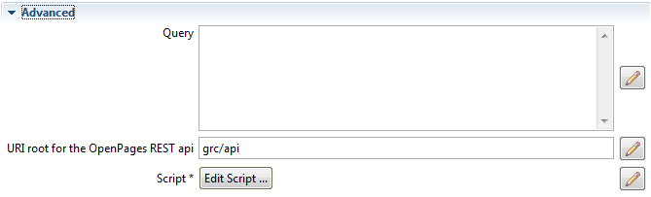
Figure 2: OpenPages Connector Connection tab – Advanced Section
The advanced parameter are described below, noting that not all parameters are available for all Connector modes.
Table 2: OpenPages Connector advanced parameters
Parameter name | Description
Query | Available for Iterator mode, this parameter can be set to the OpenPages query used to return the result set.  Note that if a Query is specified then the GRC object type is also defined by this Query, instead of by the GRC Object parameter.  If not query is specified for Iterator mode then one will automatically be generated by the Connector, selecting all fields from the type entered in the GRC Object parameter.
URI root for the  OpenPages REST api | Optional paramter to specify the start of the URI path for api requests to OpenPages.  If not specified then the default value of ‘grc/api’ is used.

Attribute Maps
The schema provided by the Connector will depend on the GRC Object selected. To illustrate, here is a screenshot of the GRC Object Connector discovering the schema of an Incident.
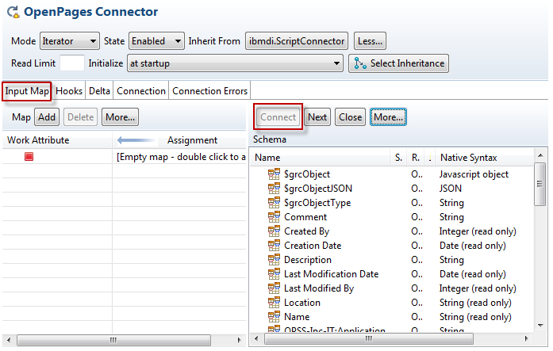
Figure 3: OpenPages Incident schema
Visible in the list are the fields of the GRC object (Incident), as well as its type as defined in OpenPages as shown above under the Native Syntax column. In addition there are three attributes prepended with a dollar sign ($). These special attributes are returned by the OpenPages Connector for all objects and their meanings are explained in the following table.
Table 3: Special CouchDB Connector Attributes
Attribute name | Description
$grcObject | A Javascript object representing the GRC Object.  By retrieving the value object for this attribute, for example with work.getObject(“$grcObject”), then the JS Object represented by the Document JSON is available for scripting.  Note that if this attribute is included for the Output Map of a write operation, its value will be used for the Document instead of other mapped attributes.
$grcObjectJSON | The JSON representation of the GRC Object.
$grcObjectType | The string name of the GRC Object type, for example ‘Incident’ or ‘SOXBusEntity’.
These attributes provide convenient access to both the JSON representation as well as the GRC object itself.

OpenPages Connector Examples
This chapter contains a few tutorial examples for using the OpenPages Connector in various modes.

Reading Incidents from OpenPages
In this example an OpenPages Connector will be configured in the Resource Library of a TDI Project. It will then be used in a new AssemblyLine to read Incidents and display these in the log output.
The first step is to create a new TDI Project by pressing the New Project button and naming this project ‘OpenPages Tutorial’.
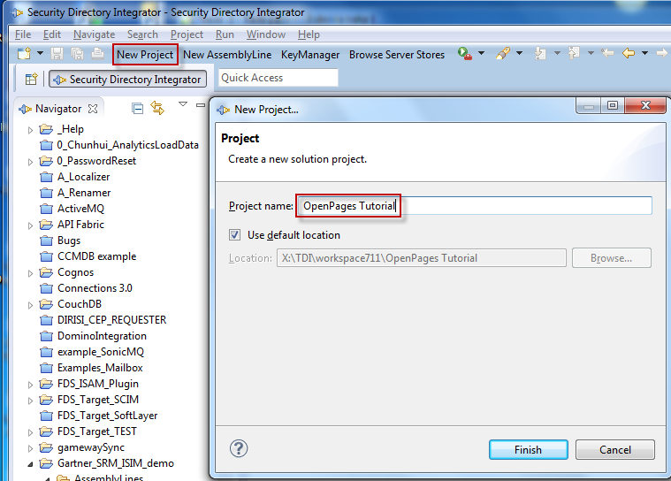
Figure 4: Creating a TDI Project
Once the project is made then resources and AssemblyLines can be created in it.

Configuring the Resource Library Connector
Although you can create new Connectors directly in an AssemblyLine, in this example you will make a Library component that can be used in multiple ALs.
In the TDI, create a new project (or choose an existing one) and then create a new Connector under the Resources > Connector library.
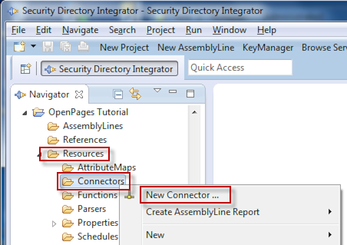
Figure 5: Creating a new library Connector
In the resulting Choose Component dialog, type ‘openpages into the Search field in order to limit the list of components shown. Then choose the OpenPages Connector item from the selection list and name it ‘OpenPages’.
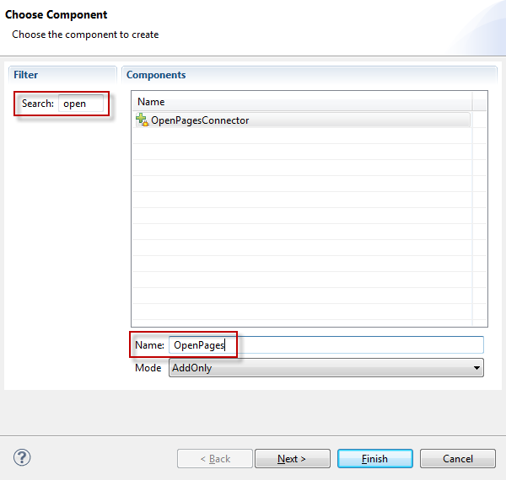
Figure 6: Selecting the OpenPages Connector

Creating Incidents in OpenPages
In this example a number of rows are read from a CSV file and used to create new Incidents in OpenPages. The steps involved will be:
- Configuring a CouchDB Connector.
- Building the AssemblyLine that uses the OpenPages Connector.
As part of building the AssemblyLine a second Connector (File) will also be configured.

Conclusion
If your AL encounters any errors then these are displayed in the log output. The first line of an TDI error message tells you the component name in brackets, followed by details of the origin of the error. Often there is a second line with more information on the cause of the exception. Should the error still prove elusive then post a question in the TDI Forum (https://ibm.biz/BdEca8) and you will get help there.
Also note that TDI is pure Java, so a Google search for the error message plus the keyword ‘java’ will likely give you clues to how you deal with this error in TDI.
Finally, there are numerous online resources for CouchDB, including explanations of various errors received.
The CouchDB Connector is a scripted component, and the script is available for you to experiment with and even enhance. Enjoy!

Appendix
TDI - Tivoli Directory Integrator (as of release 7.2 named SDI - Security Directory Integrator)
AL – Assemblyline
OpenPages – An IBM GRC management and administration system

References
OpenPages information
http://couchdb.apache.org

 ®

© Copyright IBM Corporation 2014
IBM United States of America
Produced in the United States of America
US Government Users Restricted Rights - Use, duplication or disclosure restricted by GSA ADP Schedule Contract with IBM Corp.

IBM may not offer the products, services, or features discussed in this document in other countries. Consult your local IBM representative for information on the products and services currently available in your area. Any reference to an IBM product, program, or service is not intended to state or imply that only that IBM product, program, or service may be used. Any functionally equivalent product, program, or service that does not infringe any IBM intellectual property right may be used instead. However, it is the user's responsibility to evaluate and verify the operation of any non-IBM product, program, or service.
IBM may have patents or pending patent applications covering subject matter described in this document. The furnishing of this document does not grant you any license to these patents. You can send license inquiries, in writing, to:
IBM Director of Licensing
IBM Corporation
North Castle Drive
Armonk, NY 10504-1785
U.S.A.

The following paragraph does not apply to the United Kingdom or any other country where such provisions are inconsistent with local law:
INTERNATIONAL BUSINESS MACHINES CORPORATION PROVIDES THIS PAPER “AS IS” WITHOUT WARRANTY OF ANY KIND, EITHER EXPRESS OR IMPLIED, INCLUDING, BUT NOT LIMITED TO, THE IMPLIED WARRANTIES OF NON-INFRINGEMENT, MERCHANTABILITY OR FITNESS FOR A PARTICULAR PURPOSE. Some states do not allow disclaimer of express or implied warranties in certain transactions, therefore, this statement may not apply to you.

This information could include technical inaccuracies or typographical errors. Changes may be made periodically to the information herein; these changes may be incorporated in subsequent versions of the paper. IBM may make improvements and/or changes in the product(s) and/or the program(s) described in this paper at any time without notice.

Any references in this document to non-IBM Web sites are provided for convenience only and do not in any manner serve as an endorsement of those Web sites. The materials at those Web sites are not part of the materials for this IBM product and use of those Web sites is at your own risk.

IBM may have patents or pending patent applications covering subject matter described in this document. The furnishing of this document does not give you any license to these patents. You can send license inquiries, in writing, to:

IBM Director of Licensing
IBM Corporation
4205 South Miami Boulevard
Research Triangle Park, NC 27709 U.S.A.

All statements regarding IBM's future direction or intent are subject to change or withdrawal without notice, and represent goals and objectives only.

This information is for planning purposes only. The information herein is subject to change before the products described become available.

If you are viewing this information softcopy, the photographs and color illustrations may not appear.
Trademarks
IBM, the IBM logo, and ibm.com are trademarks or registered trademarks of International Business Machines Corporation in the United States, other countries, or both. If these and other IBM trademarked terms are marked on their first occurrence in this information with a trademark symbol (® or ™), these symbols indicate U.S. registered or common law trademarks owned by IBM at the time this information was published. Such trademarks may also be registered or common law trademarks in other countries. A current list of IBM trademarks is available on the web at "Copyright and trademark information" at http://www.ibm.com/legal/copytrade.shtml.
Microsoft, Windows, Windows NT, and the Windows logo are trademarks of Microsoft Corporation in the United States, other countries, or both.
Linear Tape-Open, LTO, the LTO Logo, Ultrium, and the Ultrium logo are trademarks of HP, IBM Corp. and Quantum in the U.S. and other countries.
Other company, product, or service names may be trademarks or service marks of others.

The OpenPages Connector jar file can be downloaded from this link: https://ibm.biz/BdEHwD
Adding jar file and zip file libraries to TDI is described here: https://ibm.biz/BdFQt6 As well as here: https://ibm.biz/BdFQ6j
The term AL is often used as an abbreviation for AssemblyLine in TDI literature. It will be used throughout this document.

